Falsely Imprisoned for 23 Years: Now He’s Received $7 Million
The payout “doesn’t settle what I went through,” said Derrick Hamilton, who accused the police of fabricating evidence.
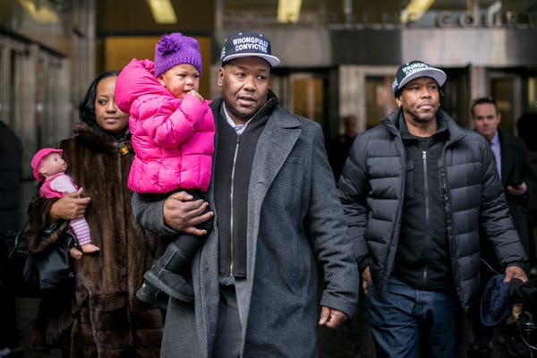

Derrick Hamilton leaving State Supreme Court in Brooklyn after his murder conviction was overturned in 2015.Credit...Anthony Lanzilote for The New York Times
By Alan Feuer
- Nov. 19, 2019
Twenty years ago, Derrick Hamilton was at his lowest point: locked in solitary confinement for a murder he insisted he did not commit. Over the next two decades, he slowly crawled his way out of the belly of the beast.
He became a jailhouse lawyer, helping his fellow inmates appeal their convictions. Twenty-three years later, he finally persuaded prosecutors to throw out his own conviction, after an eyewitness recanted her testimony. Once free, he became an activist, toiling to get others he believed were wrongfully convicted out of jail.
Late last week, Mr. Hamilton, 54, took on a new role in the long drama of his fight against injustice: a successful plaintiff. City officials in New York and New Haven, Conn., agreed on Friday to pay him a total of $7 million to settle a lawsuit he had filed against three police officers, accusing them of fabricating evidence against him.
One of those officers, Louis Scarcella, a retired New York detective, has emerged in recent years as symbol of wrongful convictions, as numerous cases he handled have fallen apart. Under the terms of the agreement, reached on the eve of what would have been a trial in Federal District Court in Brooklyn, Mr. Scarcella admitted no wrongdoing. He had been scheduled, like Mr. Hamilton himself, to testify at the trial.
For Mr. Hamilton, the payout, while substantial, was not the point. “It’ll help my family out financially,” he said. “It doesn’t settle what I went through.”
Mr. Hamilton added: “Everyone’s life went on for 20 years. Mine stopped.”
In 1991, when he was 28 and living in New Haven, Mr. Hamilton was arrested by Mr. Scarcella and the local police, accused of having murdered a Brooklyn man, Nathaniel Cash, whom he had known when he lived in the borough.
The only eyewitness against him at his trial in State Supreme Court was Mr. Cash’s girlfriend, Jewel Smith, who had given conflicting accounts to the police about Mr. Hamilton’s role in the killing.
Still, the jury convicted him, and Mr. Hamilton was sent away in 1992 to what soon became a series of upstate prisons.
He spent much of the next 23 years performing jailhouse legal work. He pored over trial transcripts, filing motions on behalf of other inmates and occasionally winning their appeals. At one point — in Attica Correctional Facility — he filed papers challenging his long stint in solitary confinement, claiming it was “cruel and unusual punishment.”
In 2007, Ms. Smith went to the authorities and asserted that Mr. Hamilton was innocent. Mr. Scarcella, she said, had coerced her into testifying against him. Eight years later, the Conviction Review Unit of the Brooklyn district attorney’s office asked a judge to toss out Mr. Hamilton’s guilty verdict. Prosecutors noted that Ms. Smith had been “unreliable, untruthful and incredible in her testimony.”
By that point, the district attorney’s office was two years into an expansive investigation of dozens of Mr. Scarcella’s former murder cases, looking into allegations that he had coerced other witnesses and had threatened people to get them to confess. That investigation, which is ongoing, has led to the release of 14 inmates and has resulted in the city and state paying tens of millions of dollars to settle lawsuits against Mr. Scarcella.

Review of 50 Brooklyn Murder Cases Ordered
The Brooklyn District Attorney’s Office is scrutinizing the cases of Louis Scarcella, a former star detective, after new revelations about disputed confessions and tactics in his record.
May 11, 2013
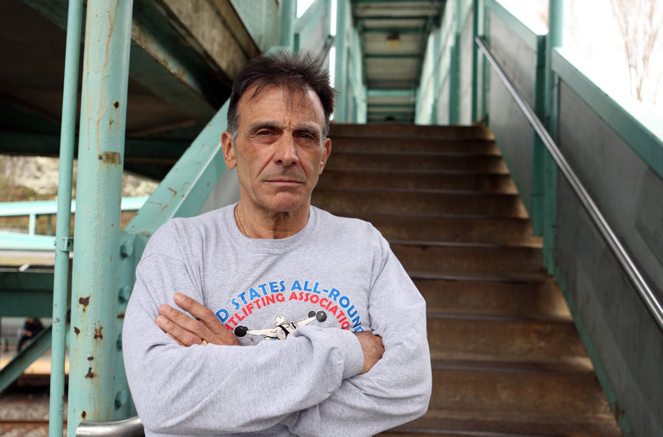

The district attorney’s office has, however, maintained that Mr. Scarcella has not committed any punishable conduct or broken the law.
Since becoming a free man, Mr. Hamilton has labored to overturn many convictions linked to Mr. Scarcella. Mr. Hamilton has worked with lawyers as a paralegal to investigate facts and has helped draft lawsuits and motions in support of new trials.
A few years ago, he founded a support group called Friends and Family of the Wrongfully Convicted with another former inmate, Sundhe Moses, who was also arrested by Mr. Scarcella and was ultimately freed.
The group met for a while at the Brownstone Bar & Restaurant on Tillary Street in Downtown Brooklyn, which Mr. Hamilton operated with Shabaka Shakur, a third man arrested by Mr. Scarcella and later exonerated. (The bar eventually closed down.)
The three former prisoners would sometimes appear at hearings where Mr. Scarcella was on the stand defending his work. They wore hats that said “Wrongfully Convicted.”
More recently, Mr. Hamilton has partnered with the Innocence Project in an effort to persuade the New York Police Department to change the way in which its officers conduct interrogations. He has also undertaken a project to organize former prison inmates to work together as a voting bloc for criminal justice reform.
On Tuesday, he was in court when a Brooklyn judge threw out the conviction of Eliseo Deleon in what was the 15th exoneration linked to Mr. Scarcella’s detective work. Mr. Deleon spent 25 years in prison for a 1996 murder committed during a botched robbery in Clinton Hill. He has long maintained that Mr. Scarcella fabricated his confession.
“I know what it’s like to come home and have nothing — that’s why I’m going,” Mr. Hamilton said before the hearing. “The guy who’s coming home, he needs to know he’s got a friend.”
Alan Feuer covers courts and criminal justice for the Metro desk. He has written about mobsters, jails, police misconduct, wrongful convictions, government corruption and El Chapo, the jailed chief of the Sinaloa drug cartel. He joined The Times in 1999.

