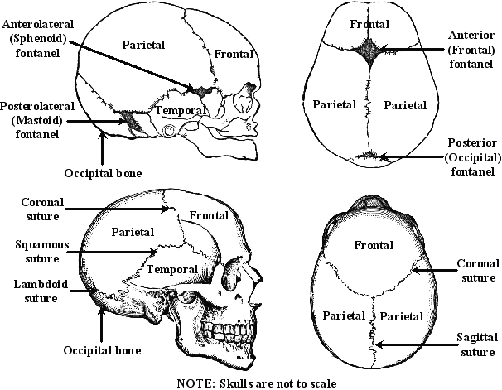

Suture Marks | Age of Fusion
Sagittal suture | Begins about age 24, closes between 30 years and 40 years old.
Sqaumous suture | Between 30 and 40 years old.
Lamboidal suture | Between 30 and 40 years old. May never fully fuse.
Coronal suture | Over 50 years old

